How to load a program onto the Arduino.
Install USB programmer Drivers
Connect USB programmer chord to the USB port of the computer. Skip getting the driver from windows. It won’t find it. Included are the most popular drivers. Point the windows driver locater to the folder “usbasp drivers”. If it doesn’t find the driver then search the web for the specific one to your operating system and install.
Connect the USB programmer to the Arduino
Remove the green board from the Arduino. It just pulls off. Connect the Programmer to the Arduino. See the image below for the orientation. The MISO pin on the programmer aligns with the “1” on the board of the Arduino.
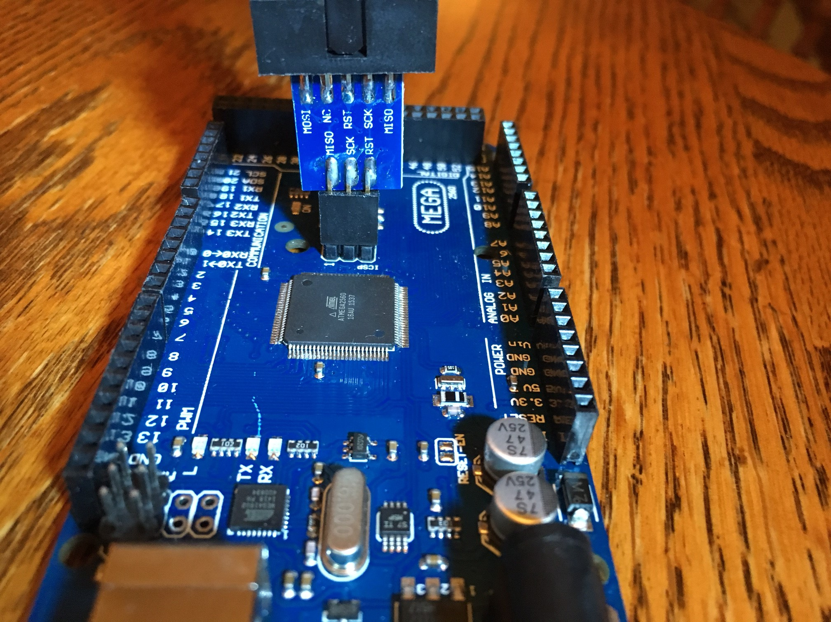

Load the program
Launch the program “LoadArduino.jar” Program is located under the Load Arduino V2 folder.
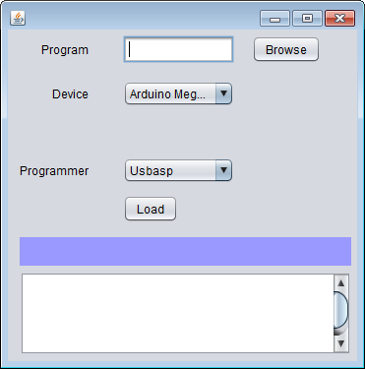
Browse to the .hex program file to load. In this case it is “PID_VPW_V008.hex”
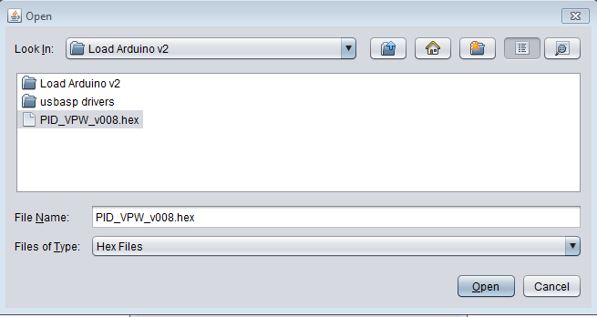
Click open.
Then click load. It will say some things followed by “writing” then “reading.
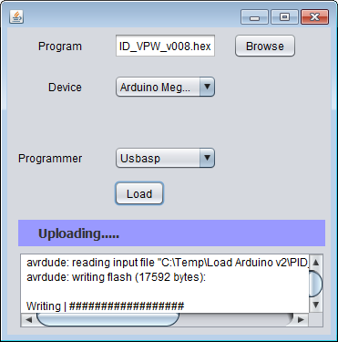
When complete you will see:
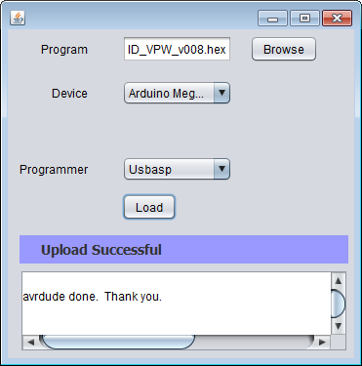
Program is loaded. Remove programmer and attached shield again.

